**Assignment No 4: Courier Management System**

**Created Database Courier Management System**

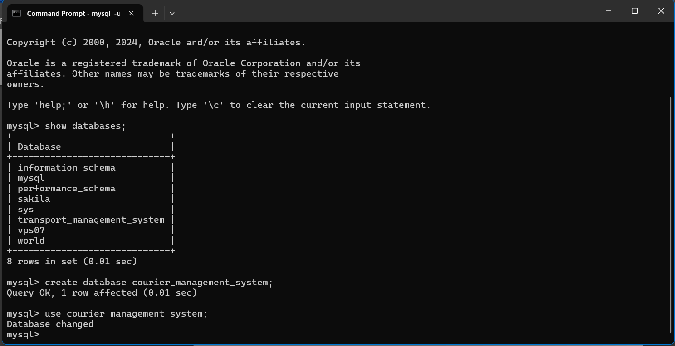

**________________________________________________________________**

**Task 1: Database Design. Created Tables i.e User Table, Courier Table, Courier Services Table, Employee Table, Location Table, Payment Table**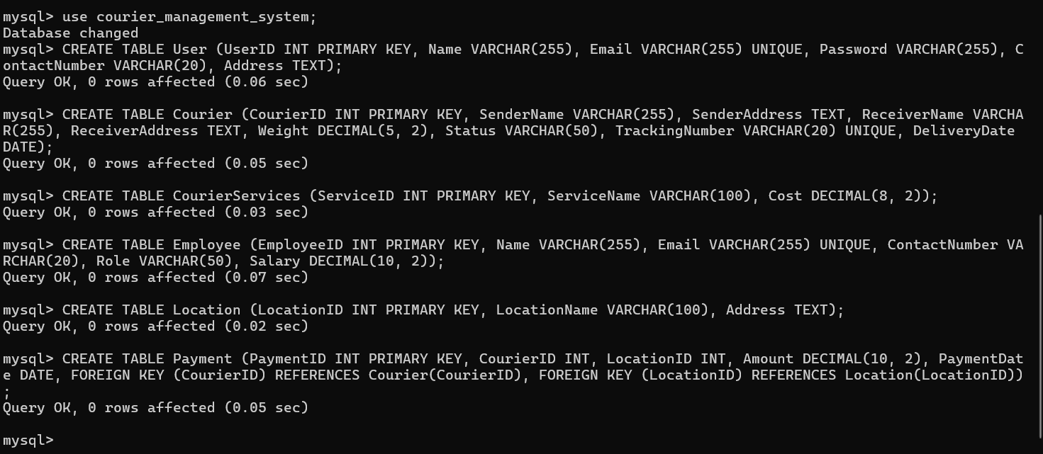

**________________________________________________________________**

**Inserted values in the tables i.e User Table, Courier Table, Courier Services Table, Employee Table, Location Table, Payment Table**

1. **User Table:**

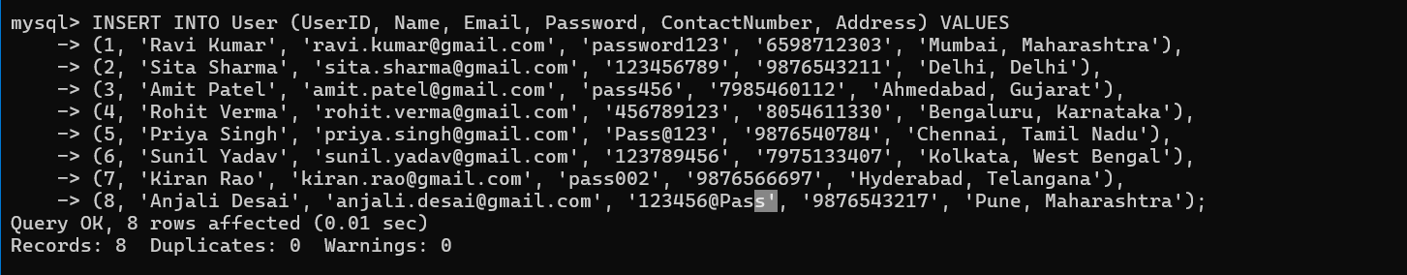

1. **Courier Table:** 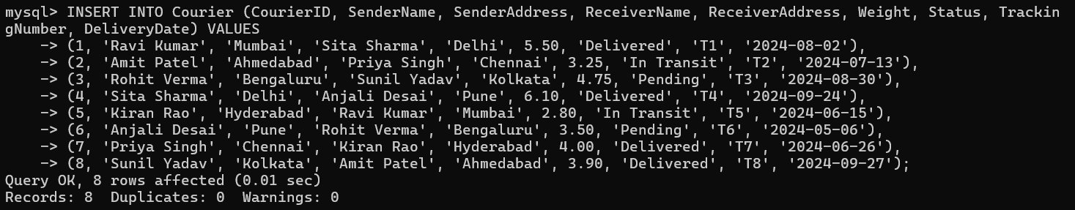
2. **Courier Services:** 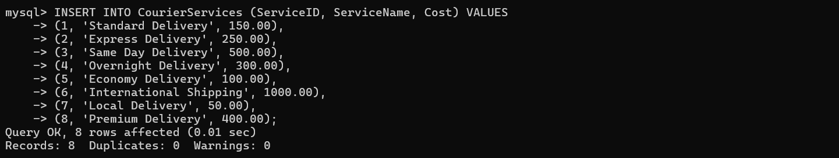
3. **Employee Table:** 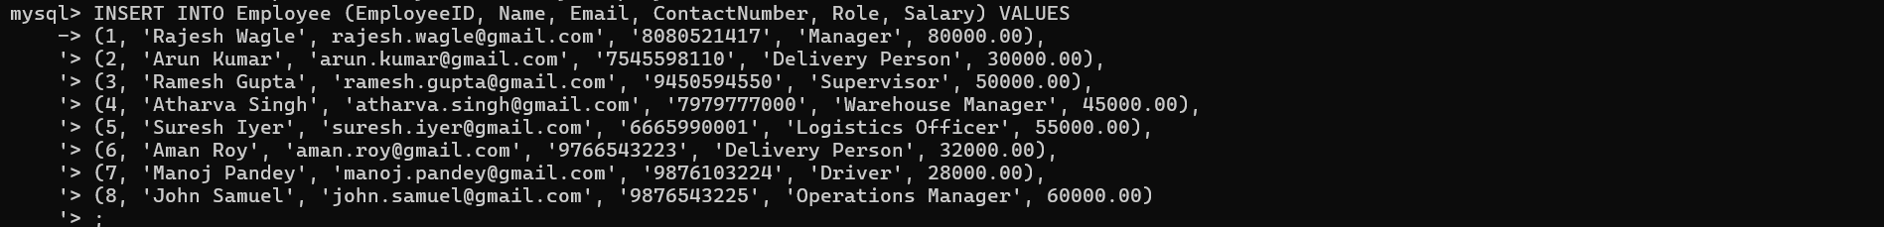
4. **Location Table:** 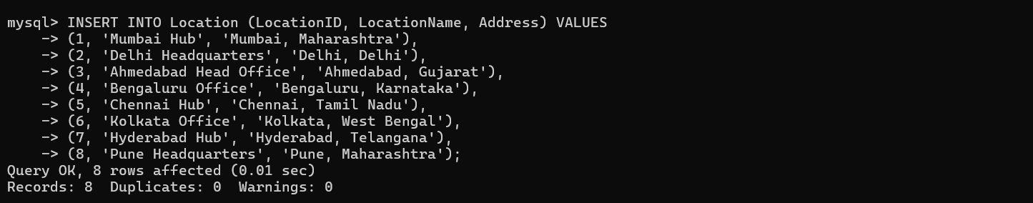
5. **Payment Table:** 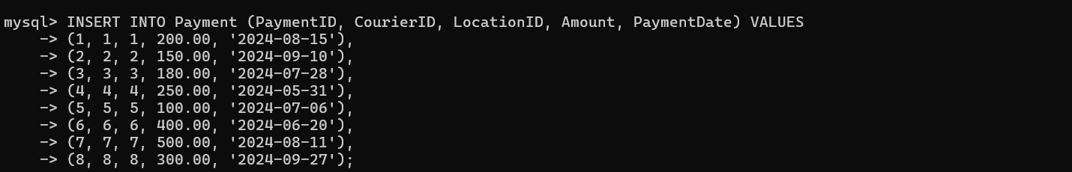

**Task 2**

1. **List all the Customers:**

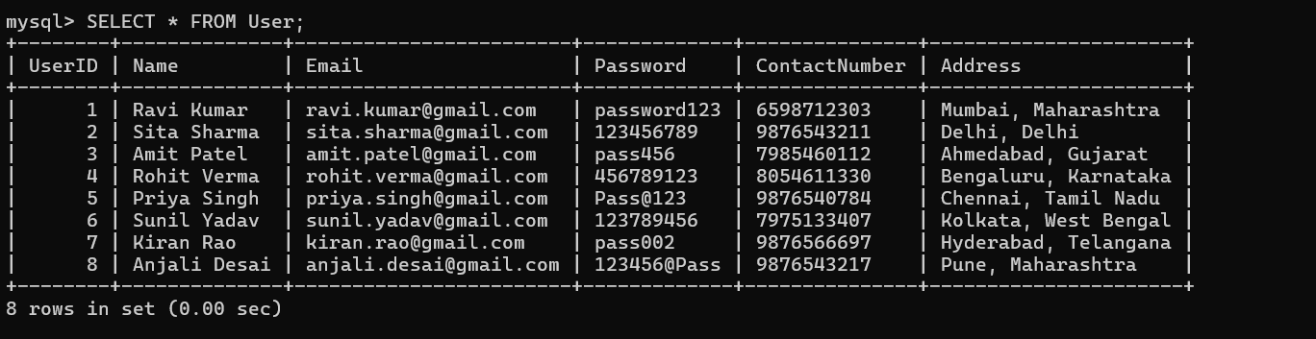

1. **List all orders for a specific customer:**

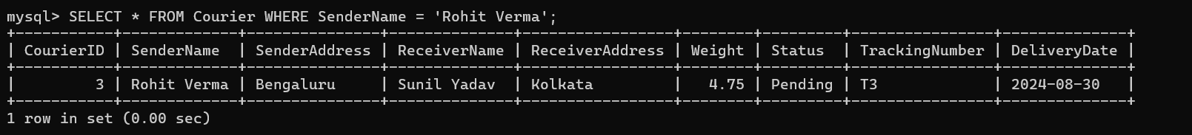

1. **List all couriers:**

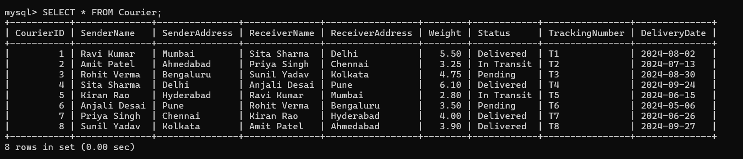

1. **List all the packages of specific order:**

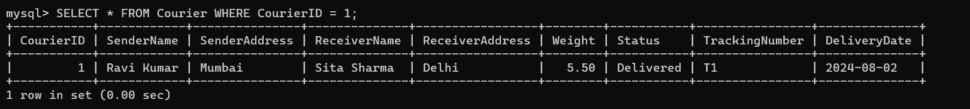

1. **List all the deliveries of specific courier:**

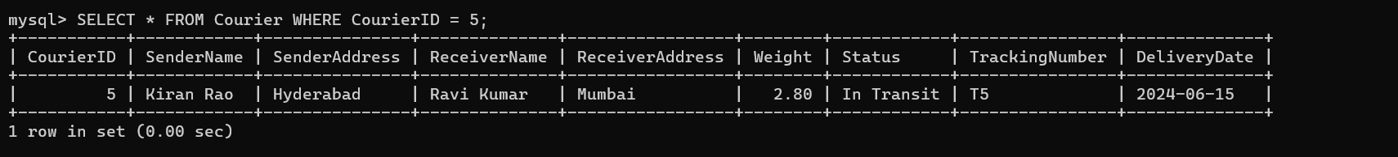

1. **List all packages that are scheduled for delivery today:**

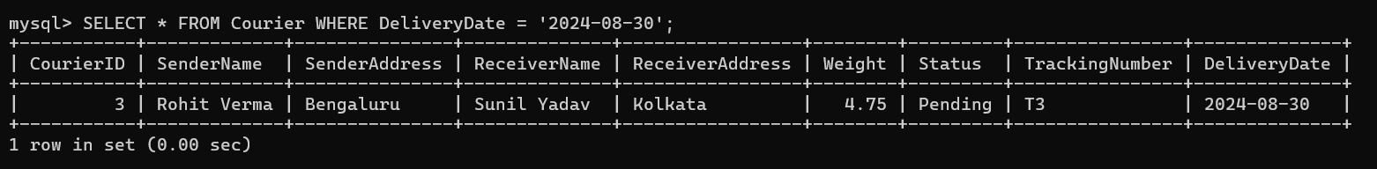

1. **List all packages with a specific status:**

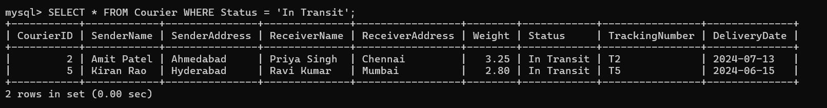

1. **Calculate the total number of packages for each courier:**

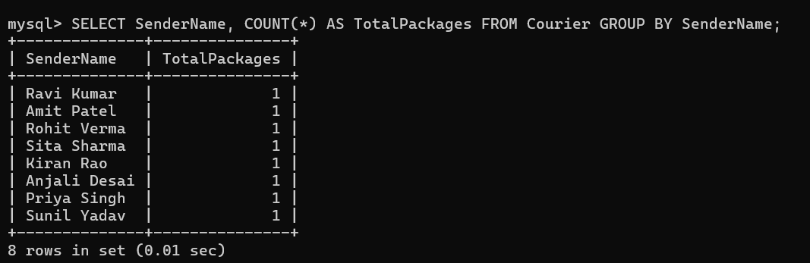

1. **Find the average delivery time for each courier:**

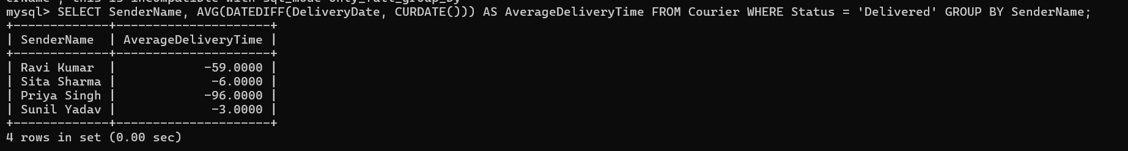

1. **List all packages with a specific weight range:**

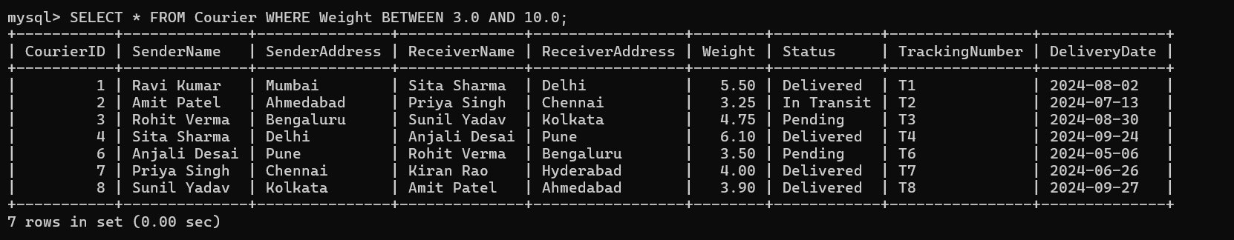

1. **Retrieve employees whose names contain 'John':**

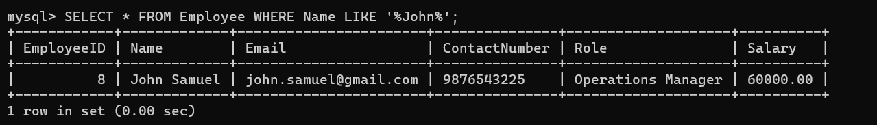

1. **List of Undelivered packages:**

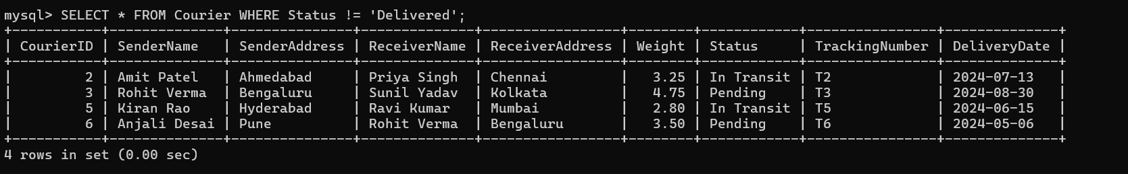

1. **Retrieve all courier records with payments greater than $50:**

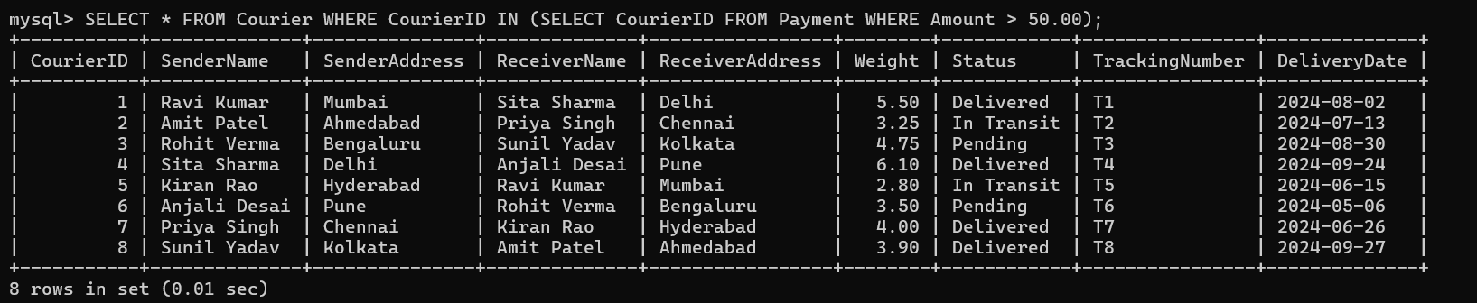

**Task 3: GroupBy, Aggregate Functions, Having, Order By, Where:**

1. **Find the total number of couriers handled by each employee:**

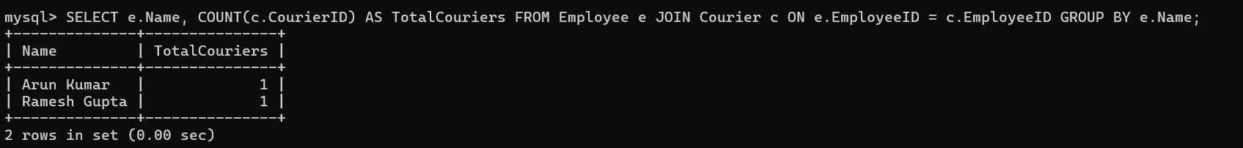

1. **Calculate the total revenue generated by each location:**

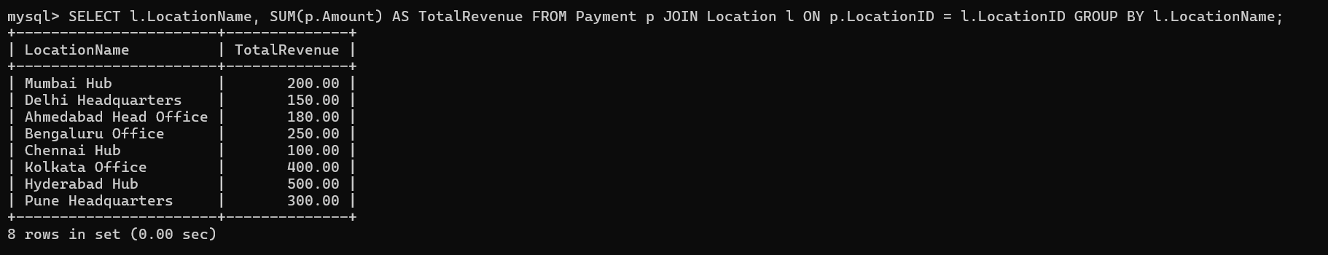

1. **Find the total number of couriers delivered to each location:**



1. **Find the courier with the highest average delivery time:**

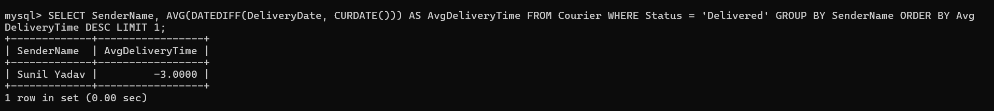

1. **Find Locations with Total Payments Less Than a Certain Amount:**

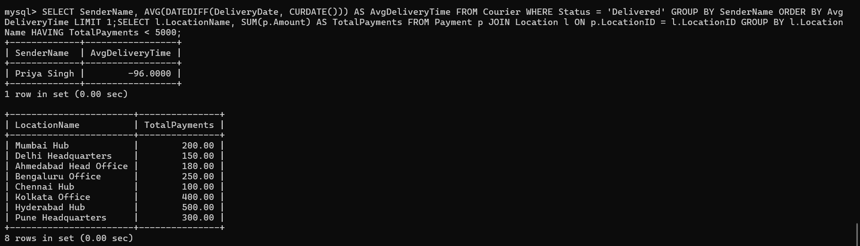

1. **Calculate Total Payments per Location:**

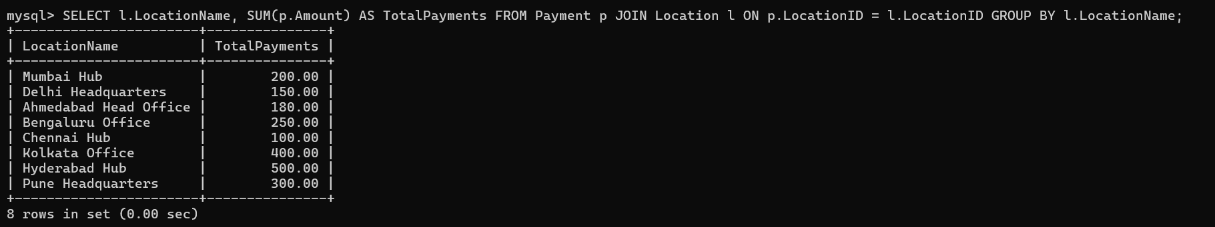

1. **Retrieve couriers who have received payments totaling more than $1000 in a specific location (LocationID = X):**



1. **Retrieve couriers who have received payments totaling more than $1000 after a certain date (PaymentDate > 'YYYY-MM-DD'):**



1. **Retrieve locations where the total amount received is more than $5000 before a certain date (PaymentDate < 'YYYY-MM-DD'):**



**Task 4: Inner Join, Full Outer Join, Cross Join, Left Outer Join, Right Outer Join:**

1. **Retrieve Payments with Courier Information:**

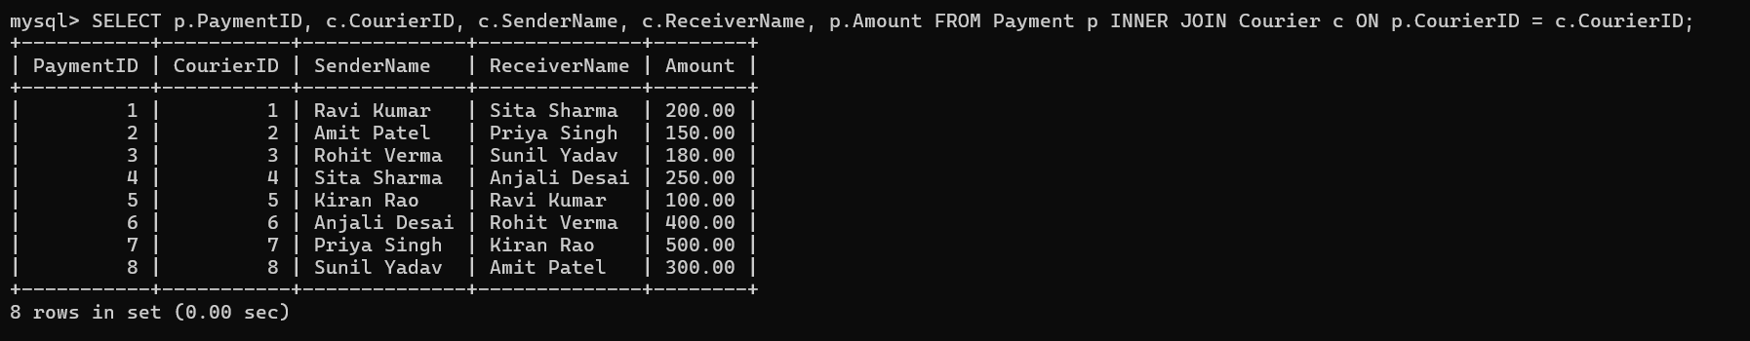

1. **Retrieve Payments with Location Information:** 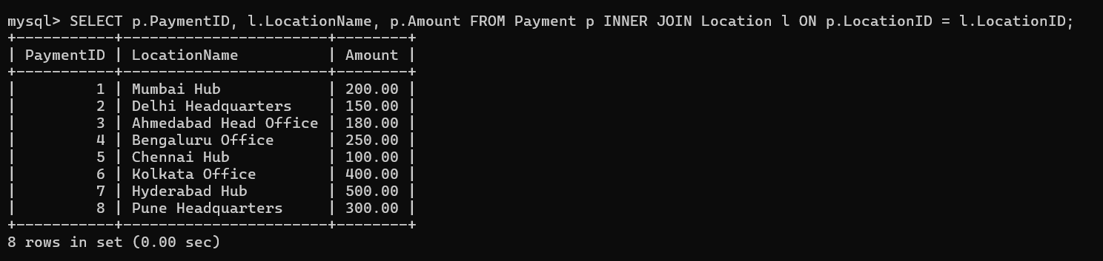
2. **Retrieve Payments with Courier and Location Information:**

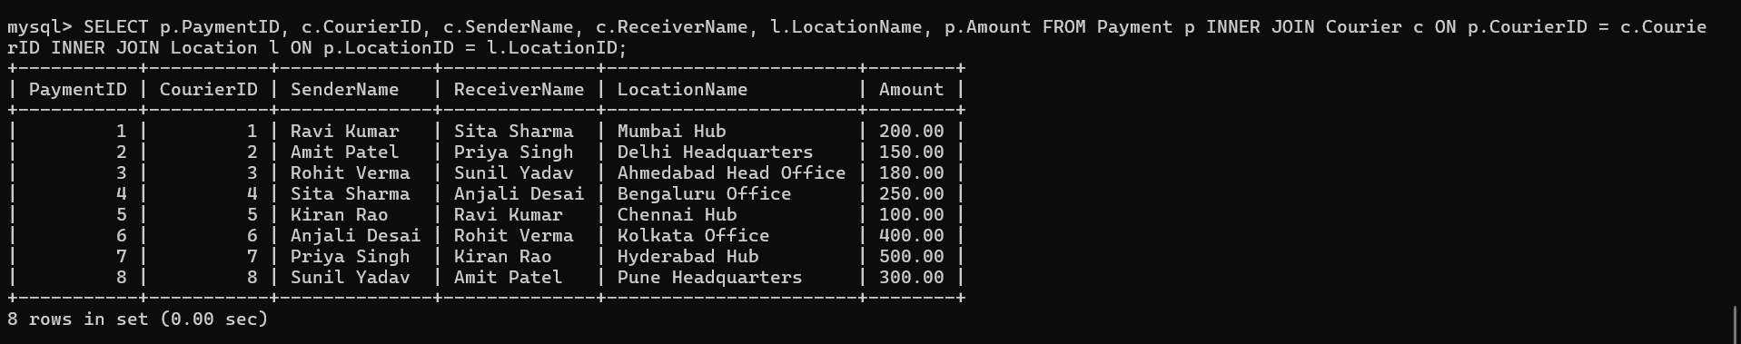

1. **List all payments with courier details:**

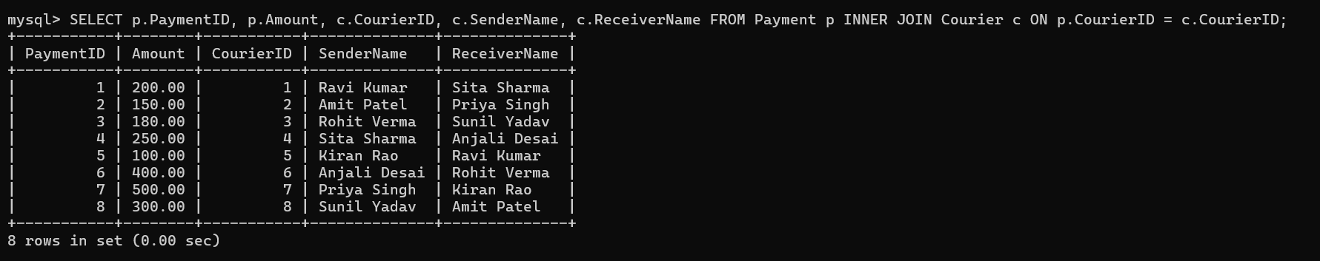

1. **Total payments received for each courier:** 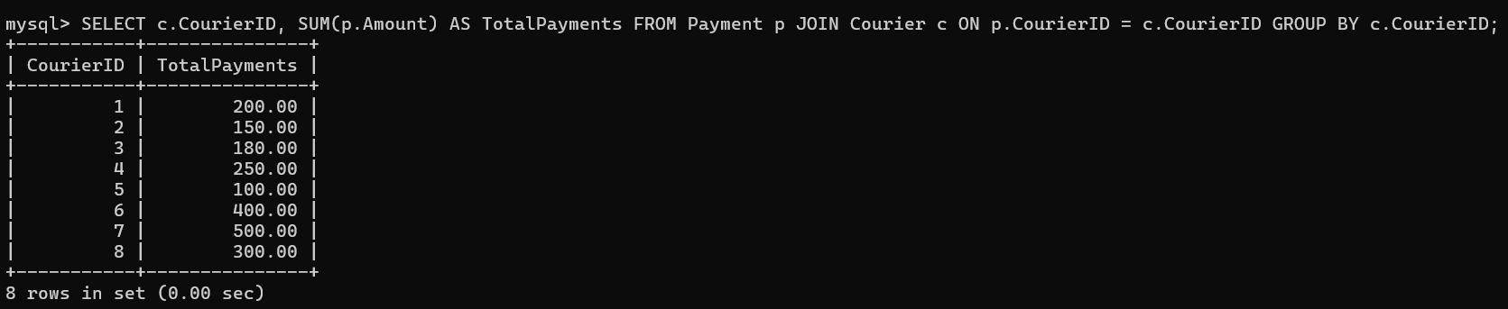
2. **List payments made on a specific date:**

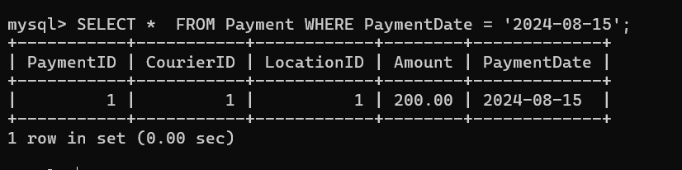

1. **Get Courier Information for Each Payment:**

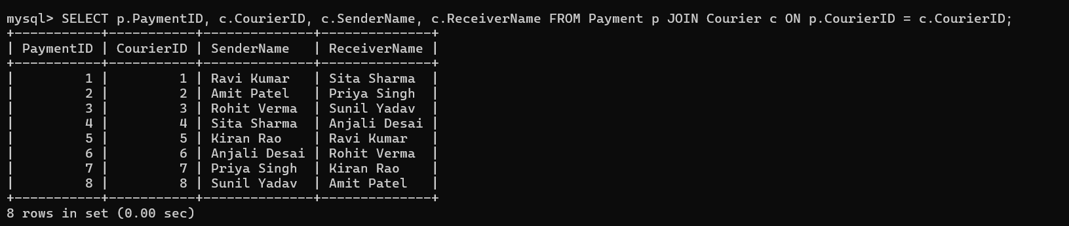

1. **Get Payment Details with Location:**

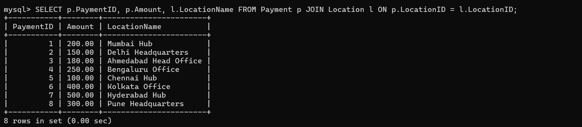

1. **Calculating Total Payments for Each Courier:**

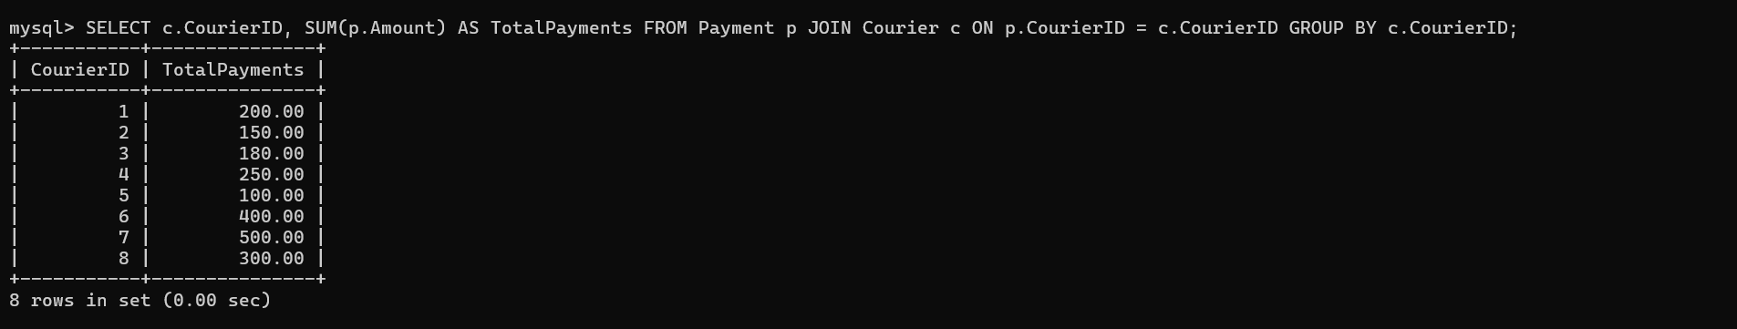

1. **List Payments Within a Date Range:**

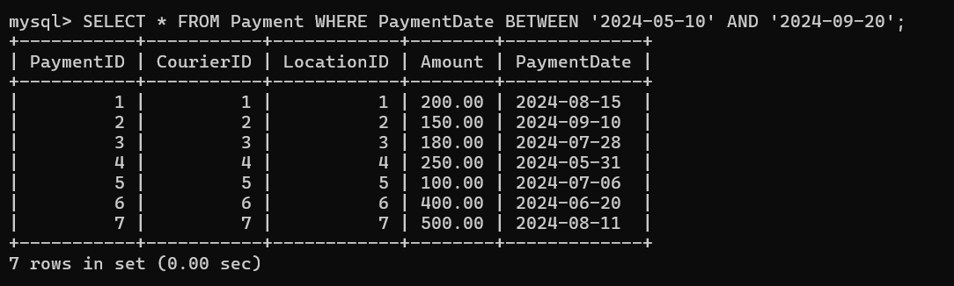

1. **Retrieve a list of all users and their corresponding courier records, including cases where there are no matches on either side:**

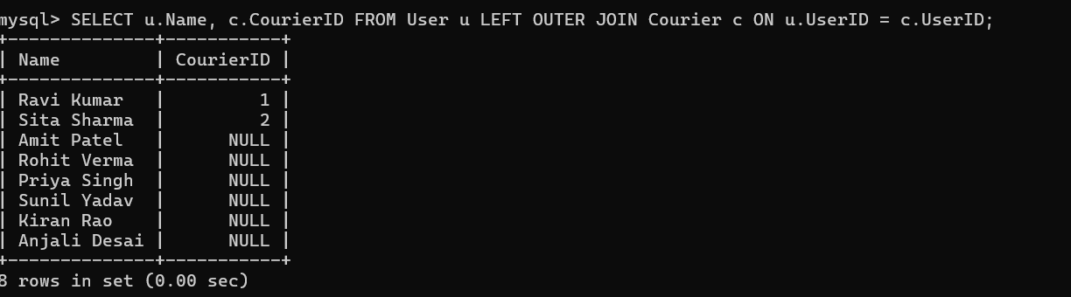

1. **Retrieve a list of all couriers and their corresponding services, including cases where there are no matches on either side:**

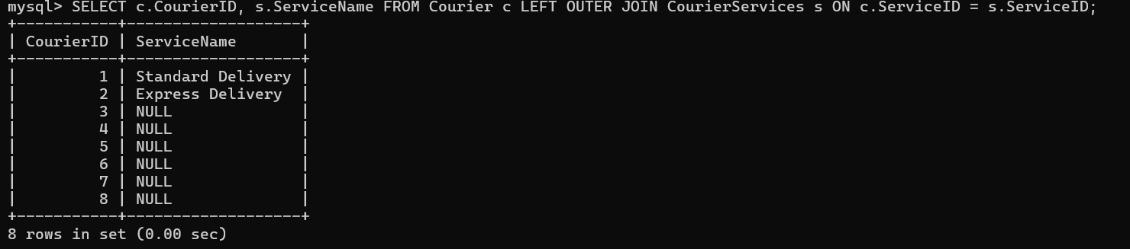

1. **Retrieve a list of all employees and their corresponding payments, including cases where there are no matches on either side:**

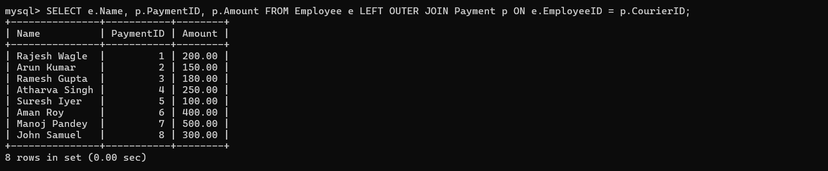

1. **List all users and all courier services, showing all possible combinations:**

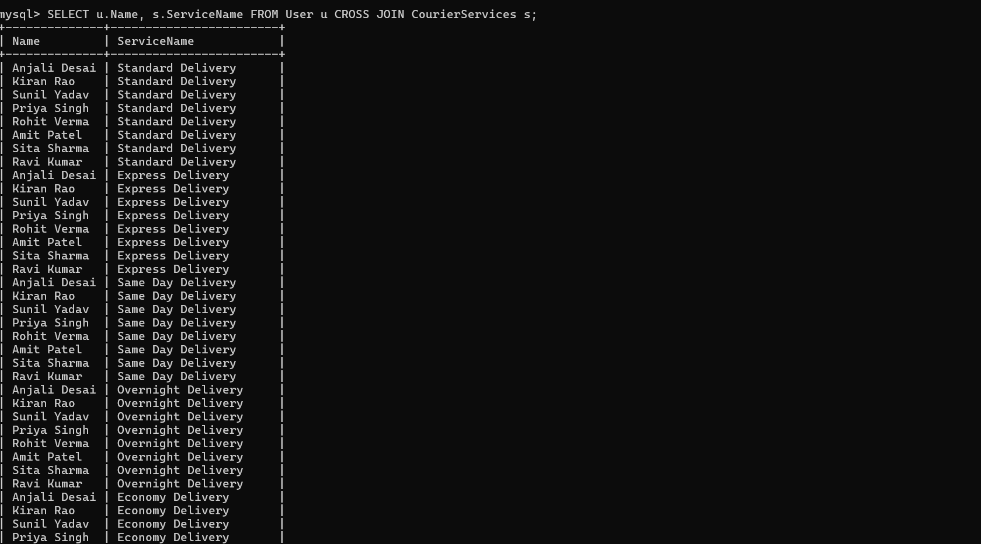

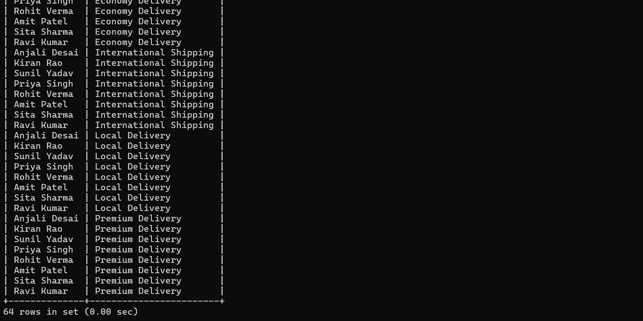

1. **List all employees and all locations, showing all possible combinations:**

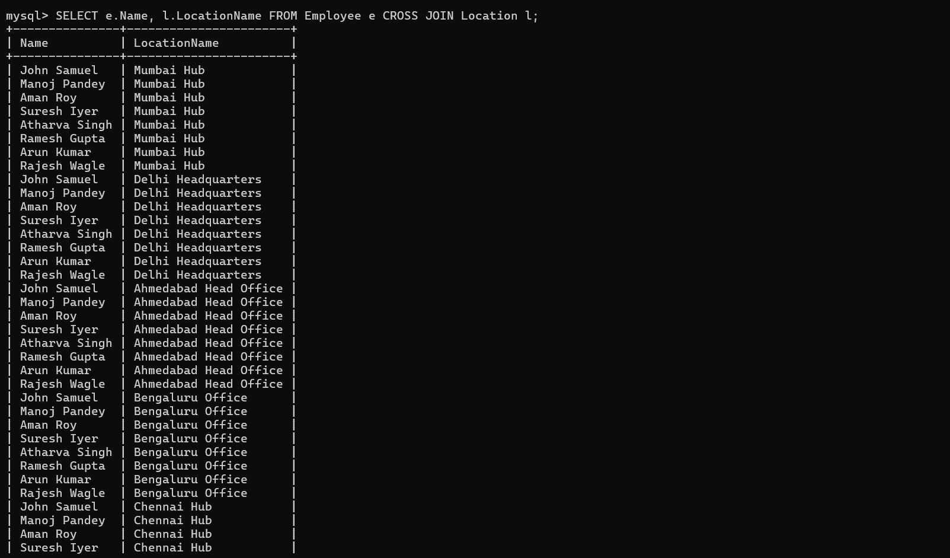

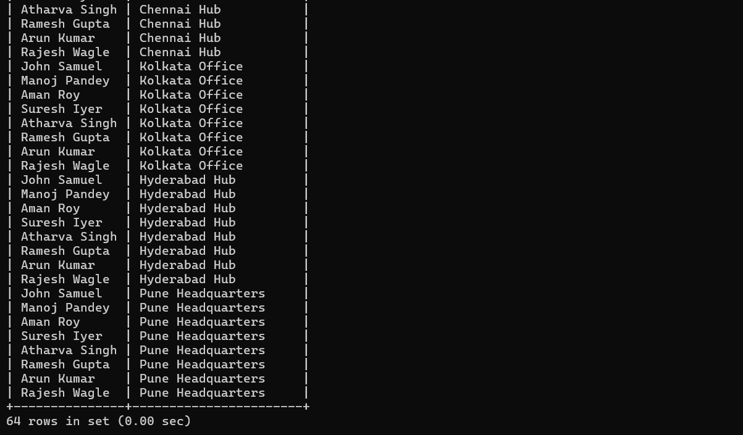

1. **Retrieve a list of couriers and their corresponding sender information (if available):**

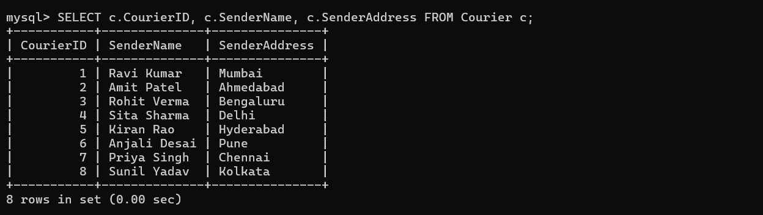

1. **Retrieve a list of couriers along with the courier service details (if available):** 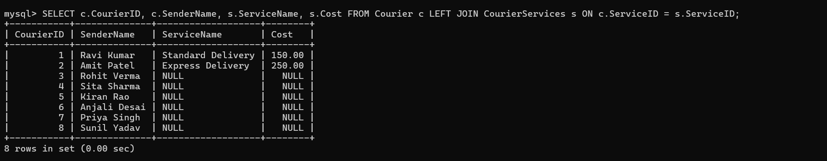
2. **Retrieve a list of employees and the number of couriers assigned to each employee:** 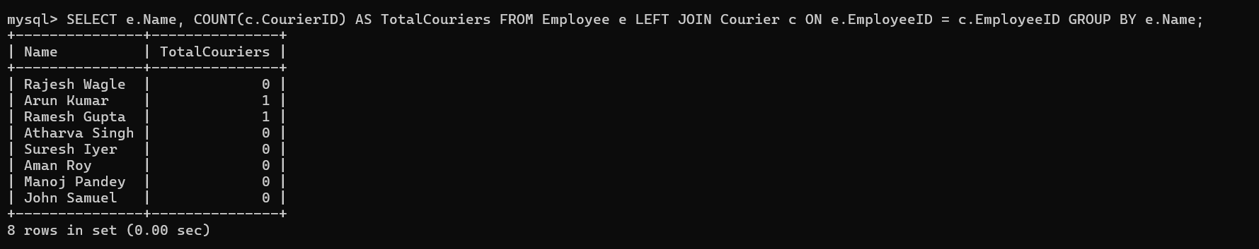
3. **Retrieve a list of locations and the total payment amount received at each location:**

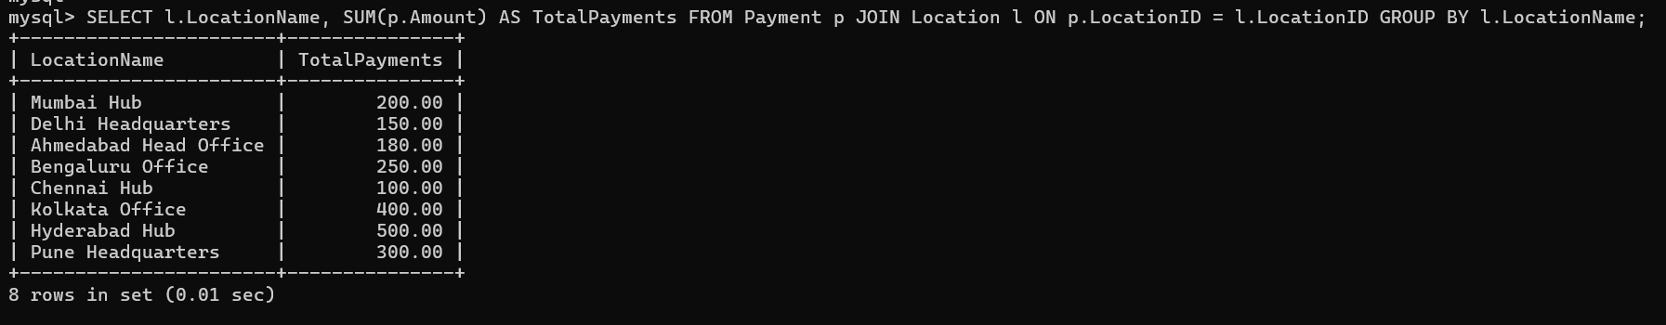

1. **Retrieve all couriers sent by the same sender (based on SenderName):**

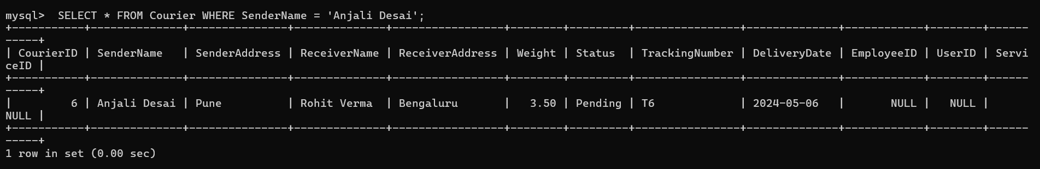

1. **List all employees who share the same role:**

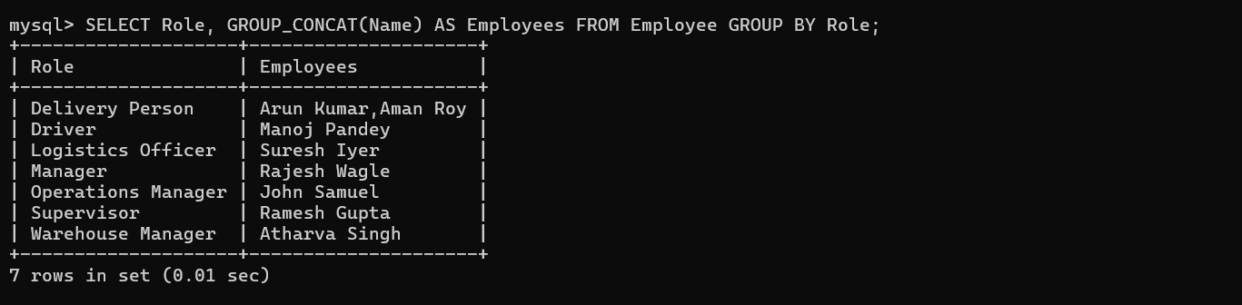

1. **Retrieve all payments made for couriers sent from the same location:**

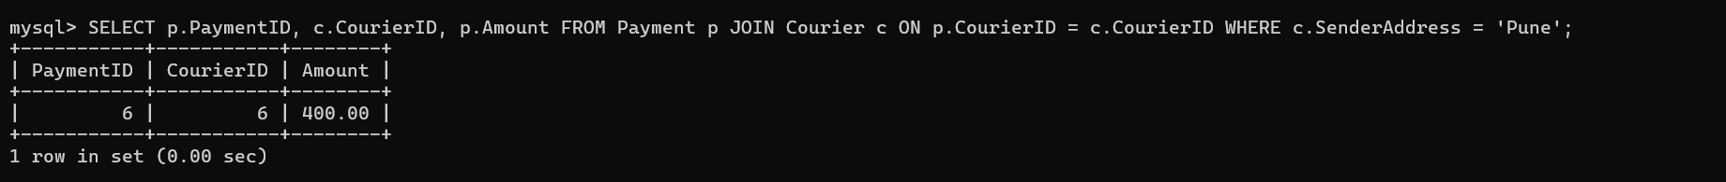

1. **Retrieve all couriers sent from the same location (based on SenderAddress):**

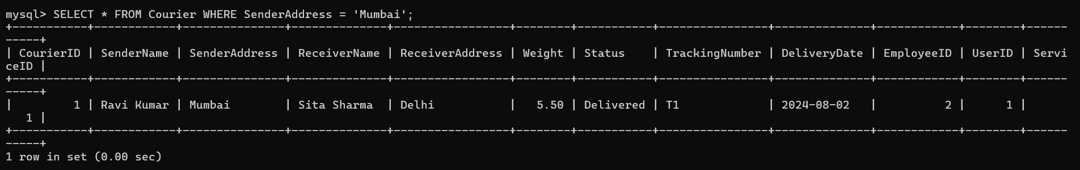

1. **List employees and the number of couriers they have delivered:**

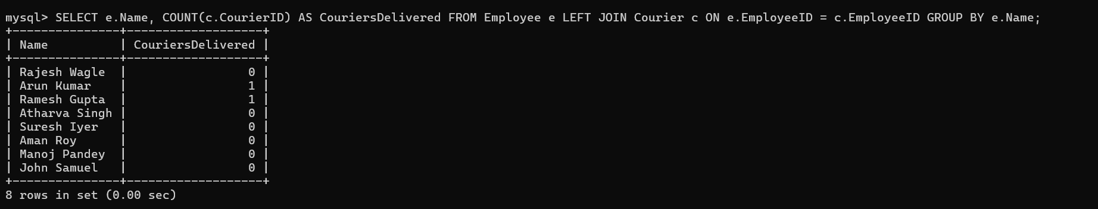

1. **Find couriers that were paid an amount greater than the cost of their respective courier services:**

